Jenkins CI/CD pipeline

1.How to install Jenkins on Linux Machine?
- First install java on linux machine for that run below command
yum install -y java-11
- After installation of java, now we need to download the Jenkins package along with key.
wget -O /etc/yum.repos.d/jenkins.repo http://pkg.jenkins.io/redhat-stable/jenkins.repo

rpm --import http://pkg.jenkins.io/redhat-stable/jenkins.io.key
- Now install the downloaded Jenkins package.
yum install Jenkins -y
- Now start and enable the Jenkins.
systemctl start jenkins

systemctl enable Jenkins
- Now check the Jenkins on browser with https://ipaddress:8080/ before that in inbound rules of security group of instance make port 8080 allow.

2.How to create a CI pipeline?
- First install git on linux machine for that go to server CLI and run below command.
yum install git -y
- After installation of git we need to install maven build tool.
- To install maven build tool, go to browser and search for index of maven and click on first result and select the desired version. Here I’m using apache-maven-3.6.3. go to /opt directory and run below command.
wget https://archive.apache.org/dist/maven/maven-3/3.6.3/binaries/apache-maven-3.6.3-bin.tar.gz
- It will download a tar package to untar it
tar -xvf apache-maven-3.6.3-bin.tar.gz
- After untaring that go to /etc/profile.d path, create a maven.sh file and add below lines and save it.
export MAVEN_HOME=/opt/ apache-maven-3.6.3-bin
export PATH=$PATH:/opt/ apache-maven-3.6.3-bin/bin
- To detect the maven path
source maven.sh
- Now run mvn -v command if it shows maven version your maven is successfully installed otherwise we need to mention java paths also.
- To mention java path got /etc/profile.d/, create a java.sh file and add below lines and save it.
export JAVA_HOME=/usr/lib/jvm/java_package_name
export JRE_HOME=/usr/lib/jvm/java_package_name/jre
export PATH=$PATH:/usr/lib/jvm/java_package_nam/bin:/usr/lib/jvm/java_package_name/jre/bin
- To detect java path run
source java.sh
- Now check for java version it should show the maven version that means you can execute maven commands locally.
- Now Git, Maven, Jenkins are installed.

Configuration of Jenkins

- Go to Jenkins UI and go to Manage Jenkins -> Global tool configuration -> Maven click on Maven installations give name, it’s our wish but whatever the we name we have provided here we will use the same name in job configuration also.
- Give maven name MAVEN_HOME if u want to mention the path of locally installed maven u can mention it like /opt/apache-maven-3.6.3 or u can install automatically by giving check mark on install automatically. For reference find below image
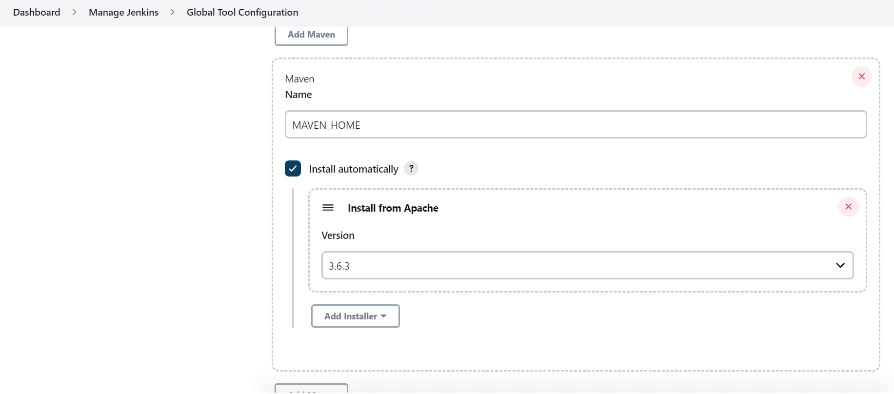
- And select the required version, in my case I have selected version 3.6.3 and save it.
Job configuration:-
- Now click on dashboard, click on new item -> select free style job and give name of the job and click on create.
- Now go to that job -> configure -> source code management -> select git -> add git credentials. Find below image for reference.

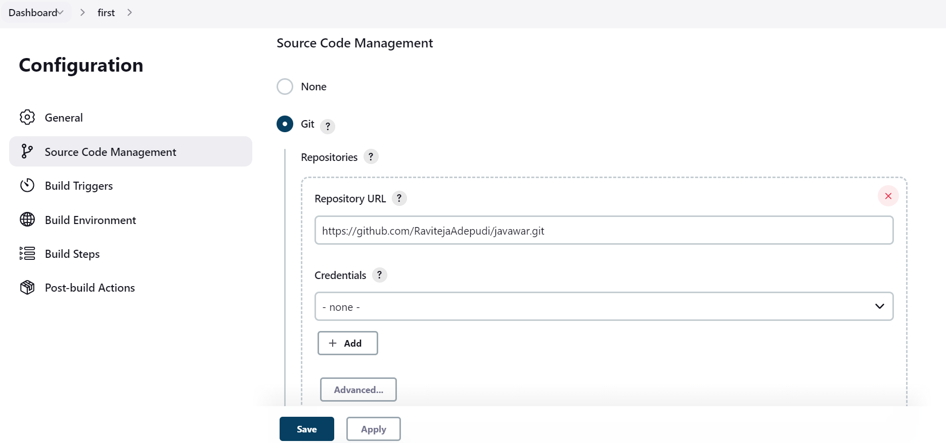
- Now go to build steps -> invoke top level maven targets -> add maven name which we added in global tool configuration MAVEN_HOME and add goal let’s say install is the maven goal, so we need to add maven goal install and save it.
- Now click on build now, the continuous integration has happened successfully.

How to create a continuous delivery/continuous deployment pipeline?
- Now go to the job which we have created click on configure -> build steps -> Execute shell add the required command to deliver the artifacts to required destination in within the server.
- If you have your Jenkins and webserver let’s say tomcat on same server. Add below command to deliver the packages to webserver path.
- Normally generated artifacts will be available under target folder /var/lib/Jenkins/workspace/job-name/target/

cp -R /var/lib/Jenkins/workspace/job-name/target/* /apache-tomcat-9.0.6/webapps/
PFB image.
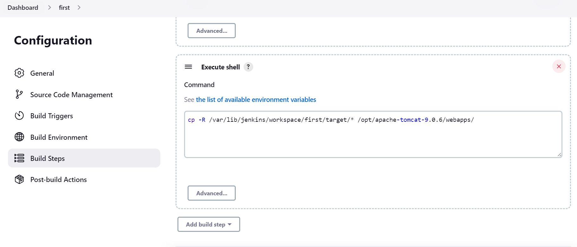
- Above command will deliver generated artifacts to desired path for every build.

